Dynatrace AI for Dynamic Environments
- The DevOps Pipeline: - Dynatrace integrates with CI/CD pipelines to enable continuous monitoring and performance analysis of applications throughout the software development lifecycle. By integrating Dynatrace into the pipeline, you can automatically monitor the performance of applications in different environments, such as development, testing, and production. This integration helps identify performance issues early in the pipeline, allowing teams to address them before they impact end-users.
- By using Ansible playbook with OneAgent we can deploy dynatrace in multiple environments.
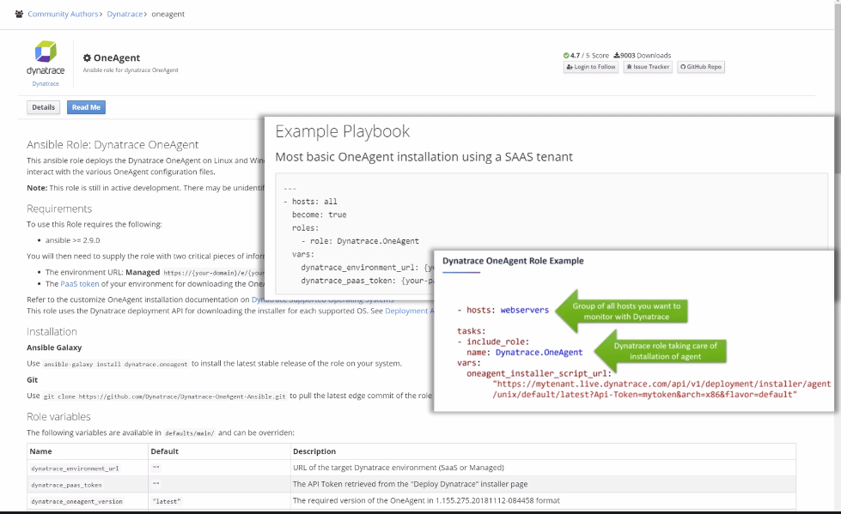
- By using OneAgent we can discover all like services, Processes and Hosts etc.
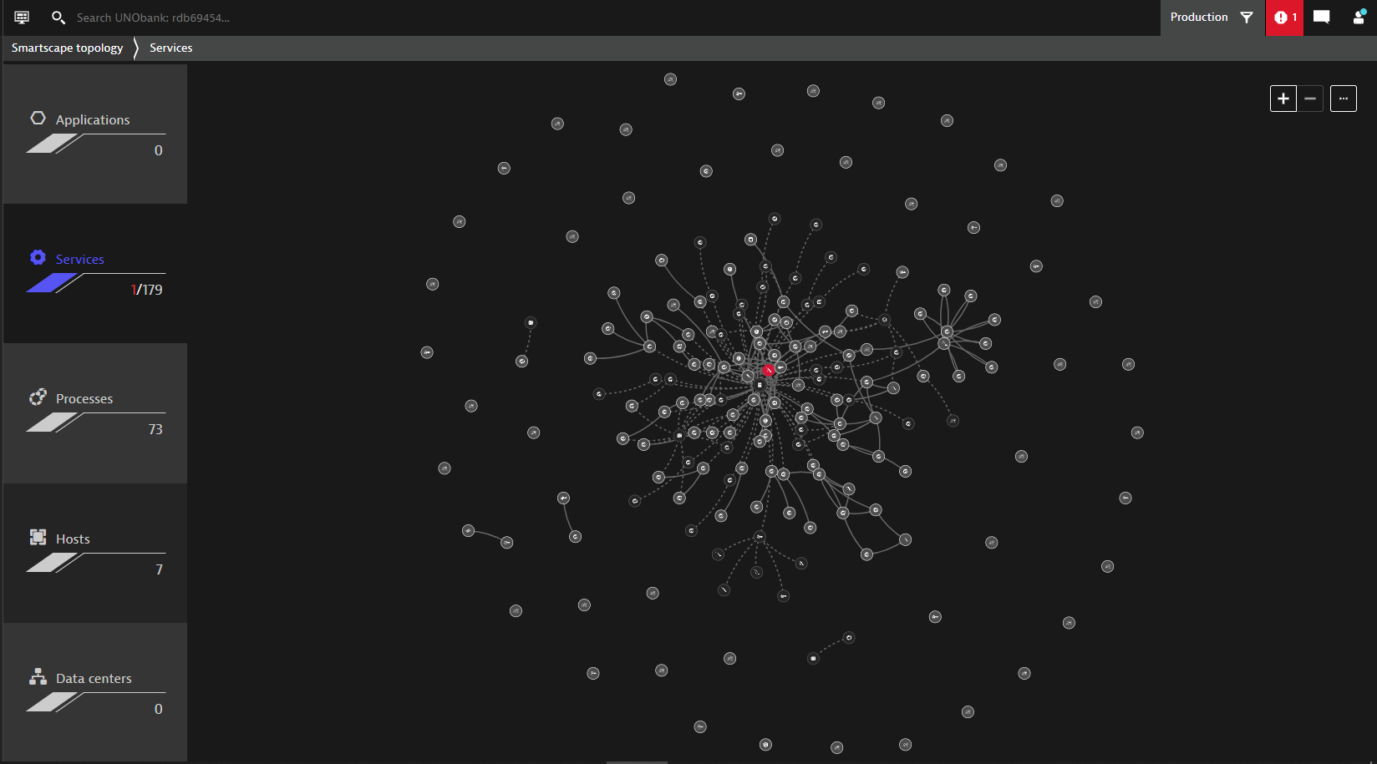
- Test Enviroment and Load Testing: - Use any of the tagging options to create tags for processes and services to organize the monitoring the data.
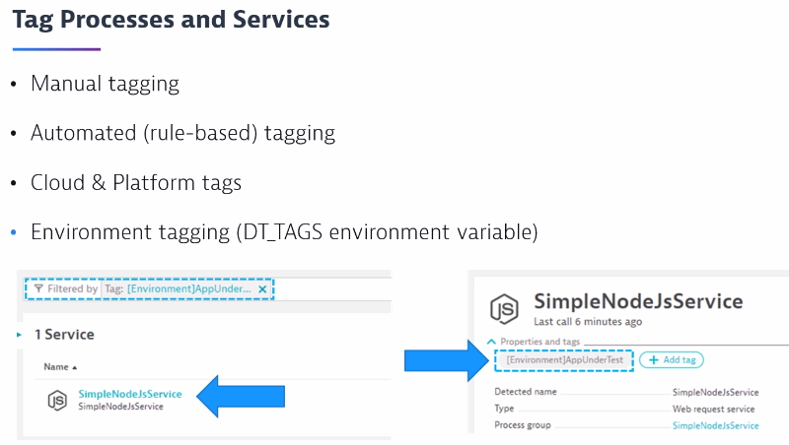
- After that setup any low testing tool
Ex: use HTTP header manger for low testing steps, so you can analyse low testing metrics from actions such as “Put item in cart” or check out.
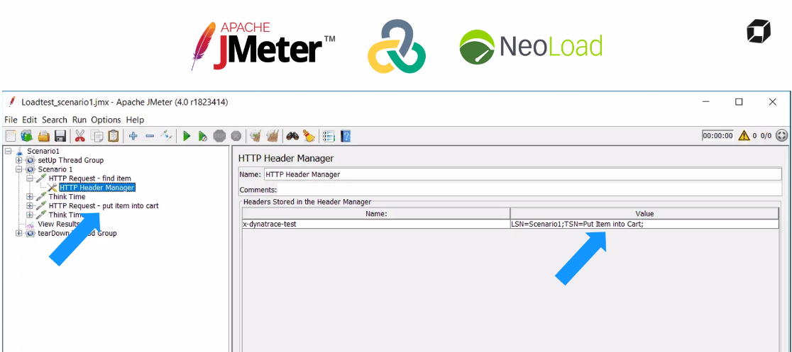
- We can also use dynatrace API to push costume events and low testing events and create request attributes.
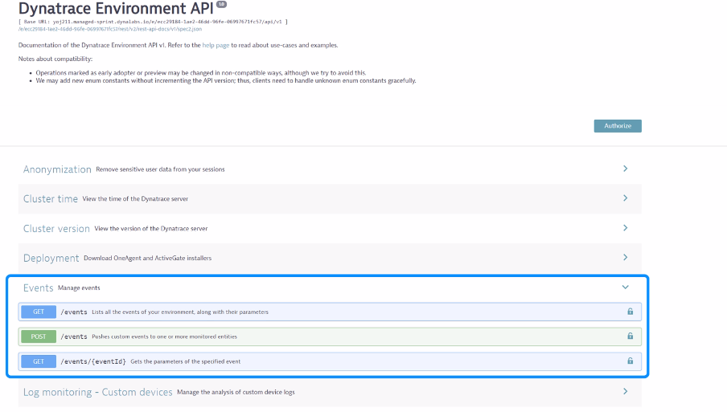
- CI/CD Pipeline Integration: - We can use tools like bitbucket, Apache and Jenkins etc.,
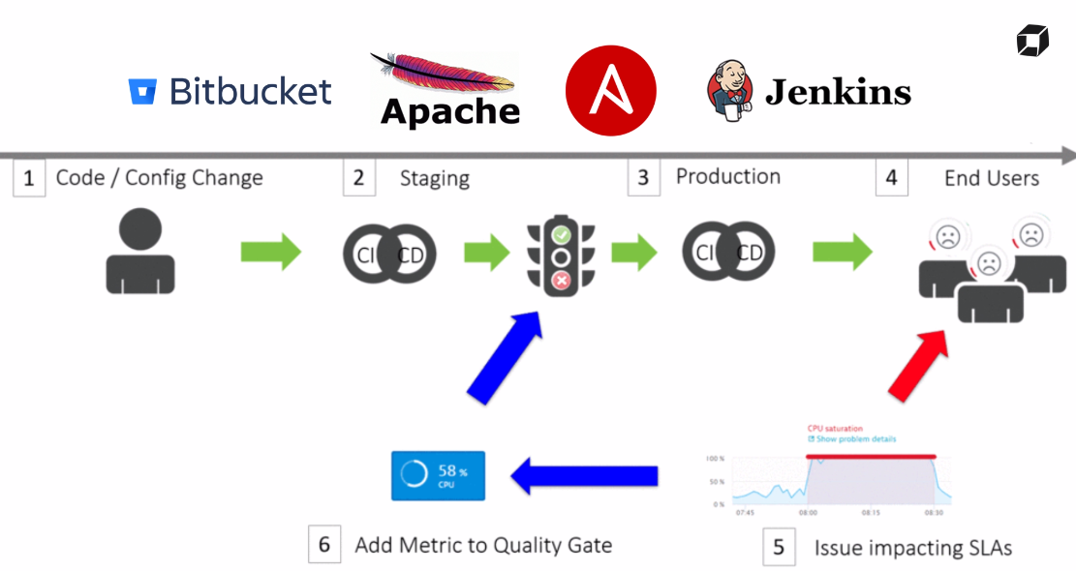

- Auto-remediation in dynatrace: - Auto-remediation refers to the automated resolution of performance issues or incidents without manual intervention. Dynatrace supports auto-remediation by integrating with various automation and orchestration tools. When Dynatrace detects a performance degradation or an issue in the monitored applications, it can trigger predefined remediation actions automatically.
- When the dynatrace AI detect the issue in the production environment have a problem notification sent to Ansible which involves a playbook that information sent from the dynatrace then it will such as back to previous version.
- We can use the role back rules by using the below methods like Workflow and Remediation rules.
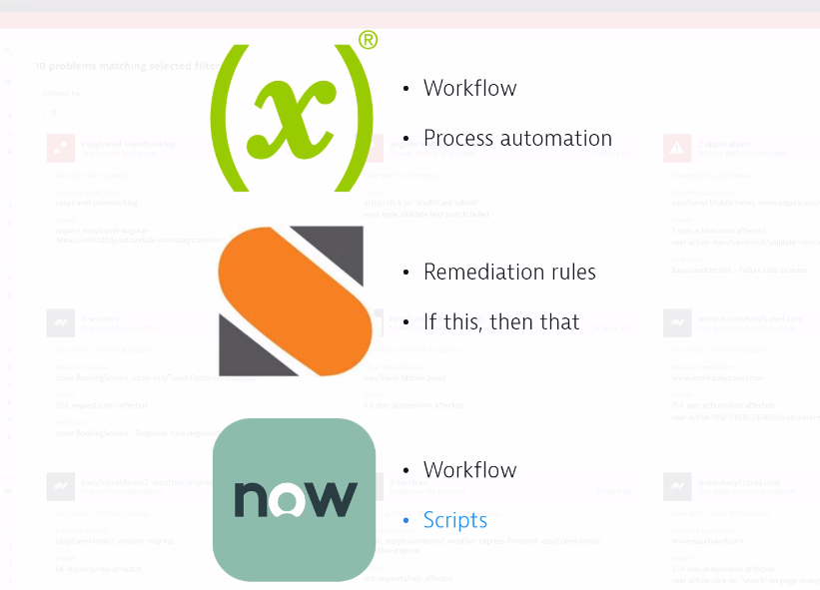

- Examining an AIOps Dashboard: - An AIOps (Artificial Intelligence for IT Operations) dashboard provides a consolidated view of various IT operational data and metrics, leveraging AI and machine learning algorithms to analyse and visualize data.
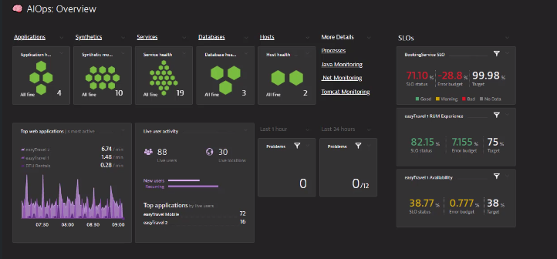
- We use BizOps configurator to create dashboards in dynatrace.
- It is a single page app and open-source software not part of the dynatrace product.
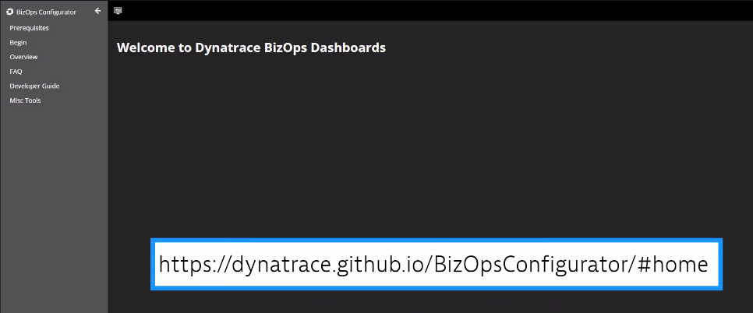
- First given the Tenant URL and APT token to begin then click on connect.
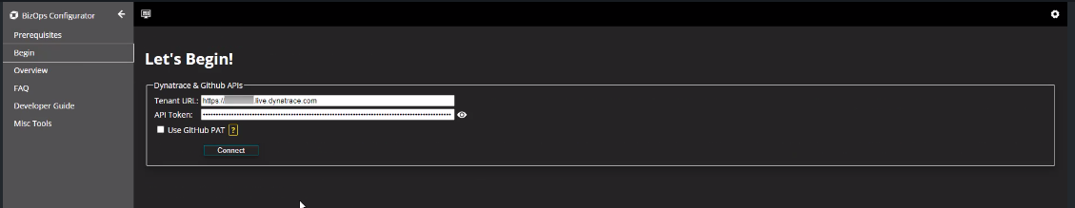
- Once done we will get multiple options click on deploy where choose your audience and use cases to get person and username and workflow.
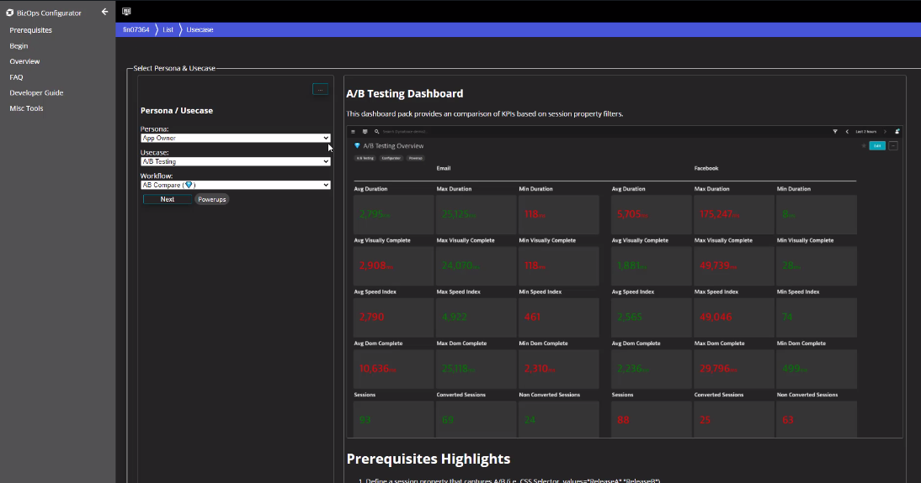
- We can create dashboard for specific technologies and application.

- How to Extend Dynatrace: - Dynatrace provides several product extensions and integrations that enhance its capabilities and allow you to integrate it with other tools and systems.
- Currently dynatrace provides visibility into the Hosts, Applications and Processes.
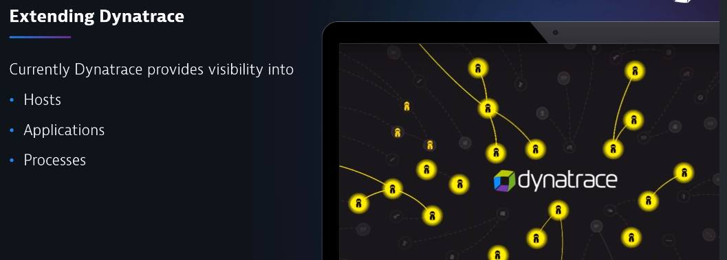
- We need some more additional components which bringing visibility on your environments.
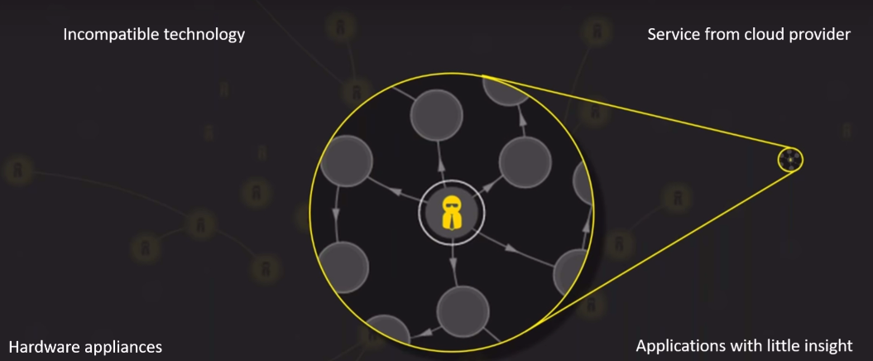
- We use every component to dynatrace extended like OneAgent, ActiveGate Extension, SDK, APT and OpenKit = Dynatrace Extended.
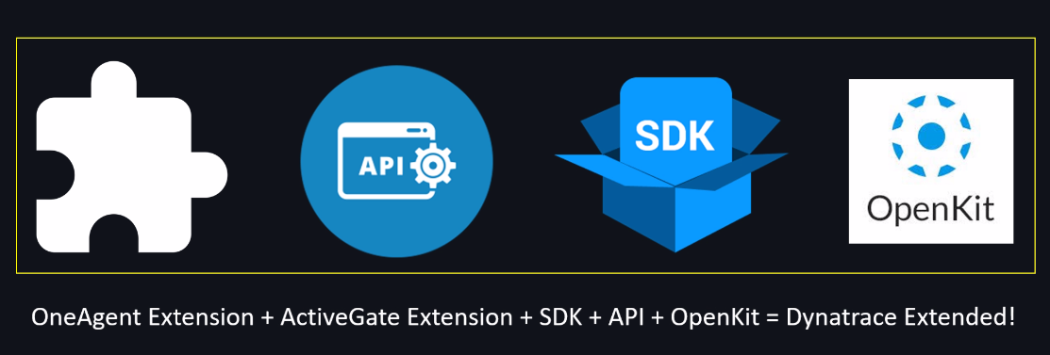
- If you want extended applications, hardware, and services within the dashboard and many other dynatrace offered.

- Extensions: -
- ActiveGate Extensions: - ActiveGate is a component of the Dynatrace monitoring platform that acts as a communication hub between the monitored environment and the Dynatrace SaaS or managed cluster.
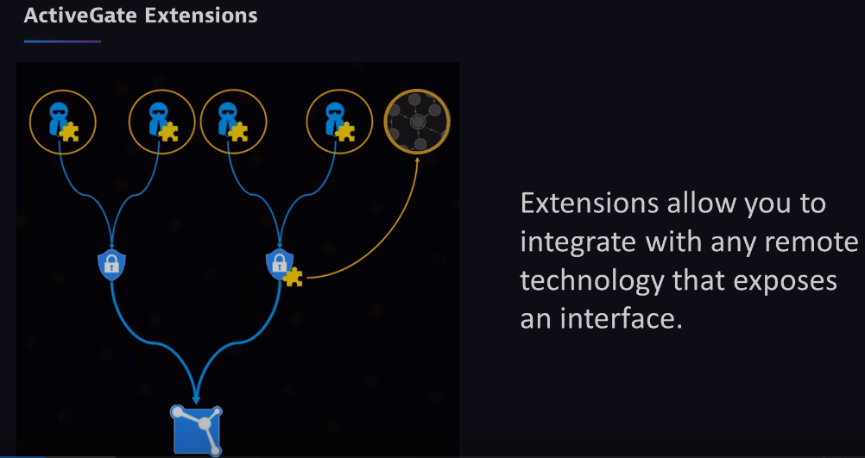
- The AI support same way for all technologies.
- ActiveGate extensions can connect remotely monitoring the technologies and each execute each minute, then uploaded to the dynatrace.
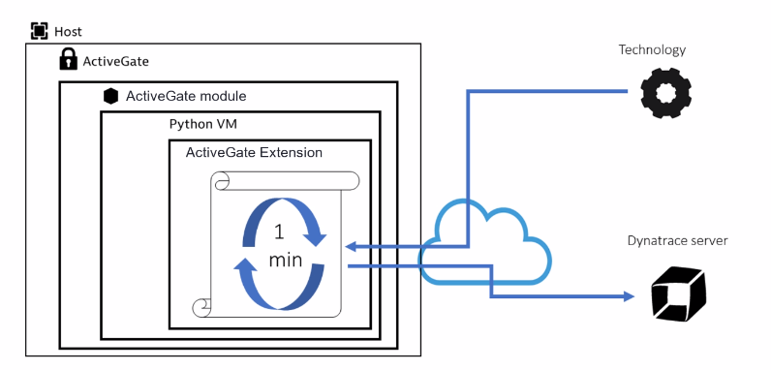
- Follow the official documents to extension the ActiveGate.

- How to create JMX Extension: - Java Management Extension.
- To create or configure JMX follow the path.
Settings Monitoring Monitoring Technologies Add new technology monitoring Add JMX extension.
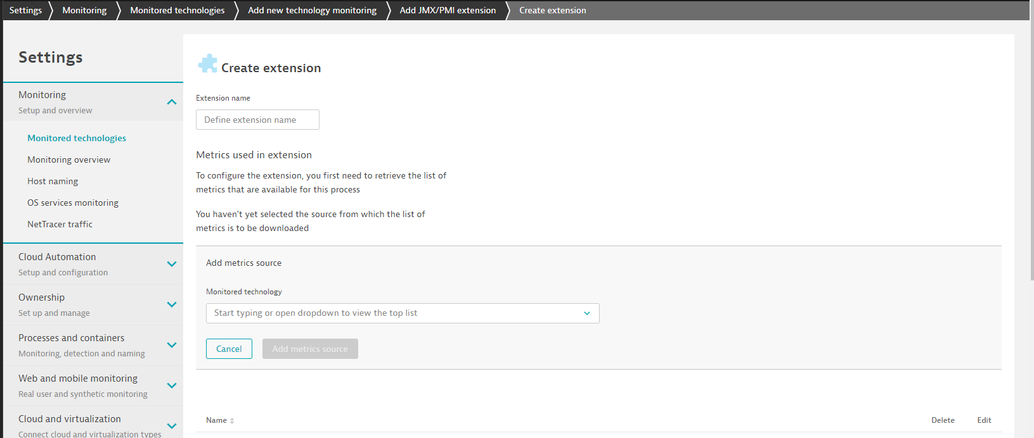

- If we want to identify the specific host or management zone also we can give on the configuration part.
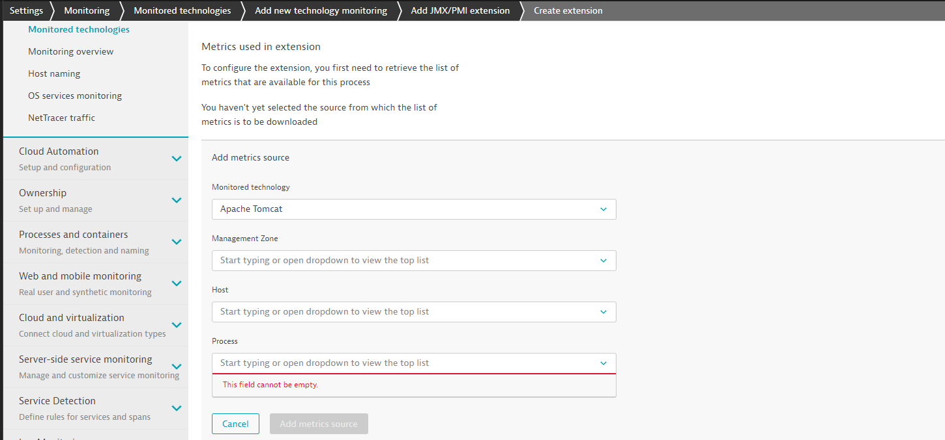
- How to create OneAgent Extension: - To create OneAgent Extension follow the below path on dynatrace dashboard and configure with required details.
- Settings Monitoring Monitoring Technologies Add new technology monitoring OneAgent Extension.
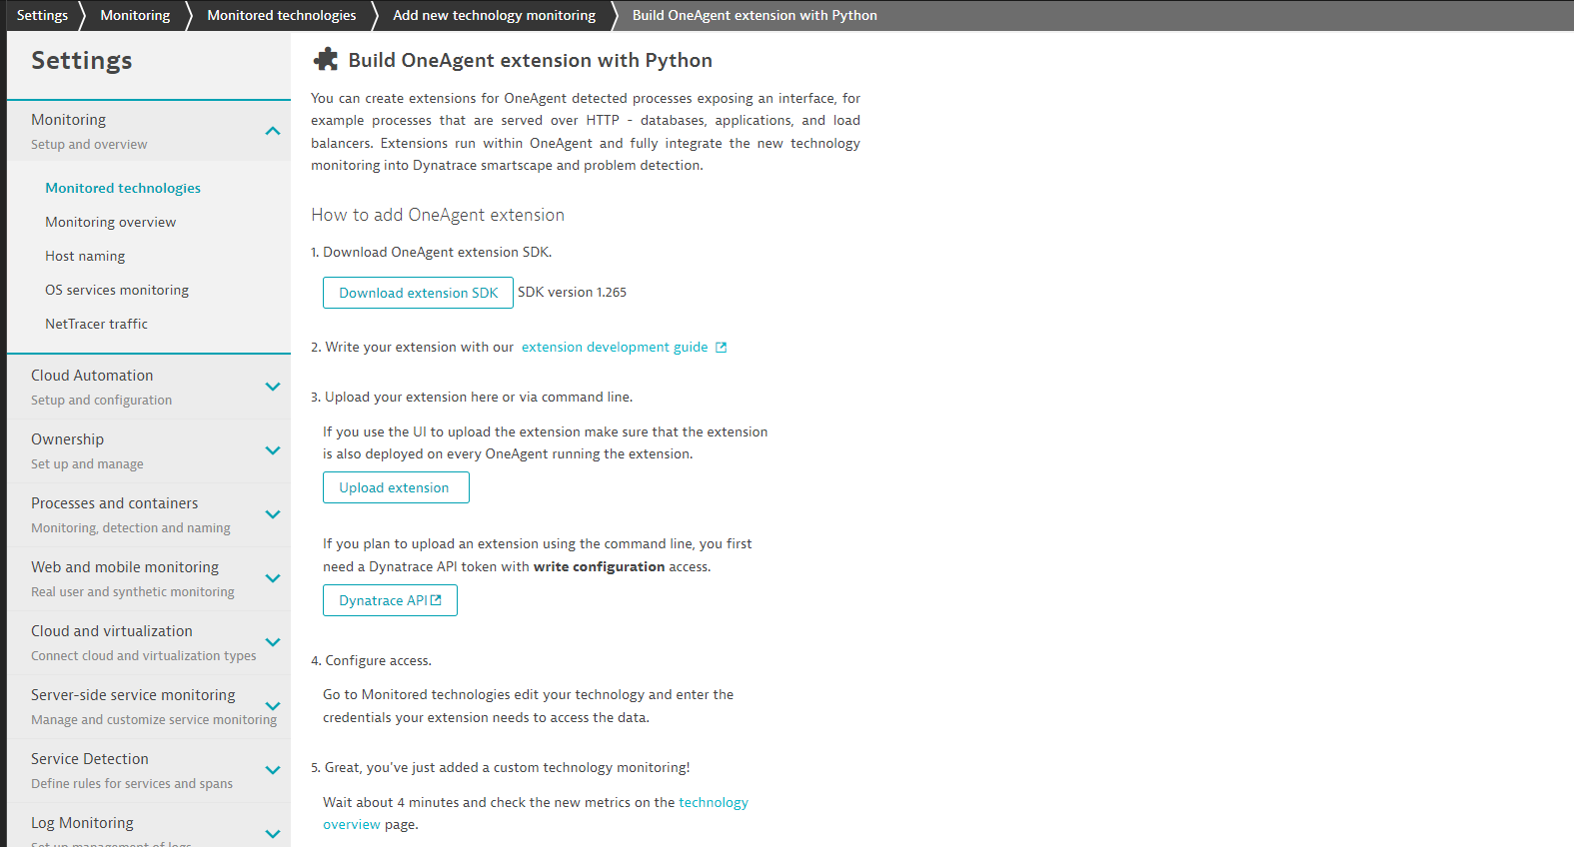

- Prerequisites to create OneAgent Extension are Phyton and Dynatrace SDK
- Check the Phyton and SDK version are valid or not.
- For development we don’t need OneAgent, but it is needed in Host with the extension will be deployed.
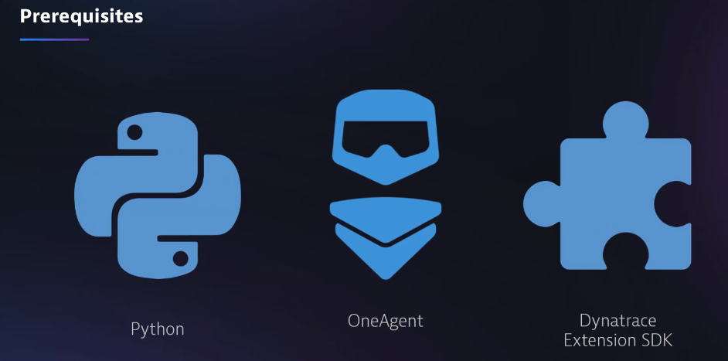

- SDK’s: - Software Development Kit
- OpenKit: - Dynatrace OpenKit is a client-side library that allows you to instrument your applications and send custom monitoring data to Dynatrace. It is particularly useful for monitoring applications that are running on platforms where Dynatrace doesn't have native support, such as IoT devices, gaming consoles, or embedded systems.
- Dynatrace is used to communicate with all the application like Rich client application and Digital touchpoints such as Television and car’s etc.
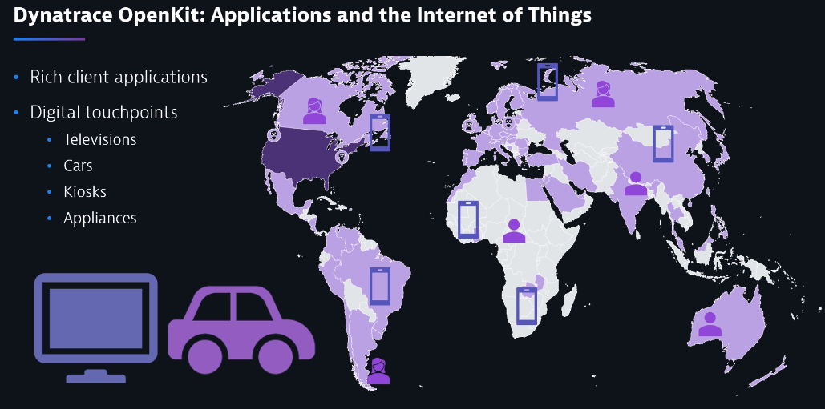
- We can check the capabilities with OpenKit.
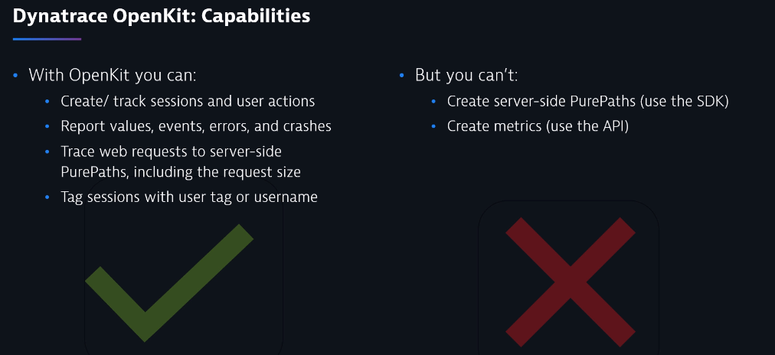
- To Installation the monitor a custom application we can follow the procedure.
- Click on dashboard and navigate to Deploy dynatrace monitor a custom application.
- Give the name as required and select the technology as we required like java or .net….
